Name | Siddhesh Sonar
UID no. | 2021700063
Experiment No. | 6

AIM: | To implement Dijkstra’s Algorithm
Program
PROBLEM STATEMENT : | To implement Dijkstra’s Algorithm
ALGORITHM/  THEORY: | 1. Create cost matrix C[ ][ ] from adjacency matrix adj[ ][ ]. C[i][j] is the cost of going from vertex i to vertex j. If there is no edge between vertices i and j then C[i][j] is infinity.  2. Array visited[ ] is initialized to zero.  for(i=0;i<n;i++)  visited[i]=0;  3. If the vertex 0 is the source vertex then visited[0] is marked as 1.  4. Create the distance matrix, by storing the cost of vertices from vertex no. 0 to n-1 from the source vertex 0.  for(i=1;i<n;i++)  distance[i]=cost[0][i];  Initially, distance of source vertex is taken as 0. i.e. distance[0]=0;  5. for(i=1;i<n;i++)  – Choose a vertex w, such that distance[w] is minimum and visited[w] is 0. Mark visited[w] as 1.  – Recalculate the shortest distance of remaining vertices from the source.  – Only, the vertices not marked as 1 in array visited[ ] should be considered for recalculation of distance. i.e. for each vertex v  if(visited[v]==0)  distance[v]=min(distance[v],  distance[w]+cost[w][v])
PROGRAM: | #include <stdio.h>  #include <conio.h>  #define INFINITY 9999  #define MAX 10  void dijkstra(int G[MAX][MAX], int n, int startnode)  {  int cost[MAX][MAX], distance[MAX], pred[MAX];  int visited[MAX], count, mindistance, nextnode, i, j;  for (i = 0; i < n; i++)  for (j = 0; j < n; j++)  if (G[i][j] == 0)  {  cost[i][j] = INFINITY;  }  else  {  cost[i][j] = G[i][j];  }  for (i = 0; i < n; i++)  {  distance[i] = cost[startnode][i];  pred[i] = startnode;  visited[i] = 0;  }  distance[startnode] = 0;  visited[startnode] = 1;  count = 1;  while (count < n - 1)  {  mindistance = INFINITY;  for (i = 0; i < n; i++)  if (distance[i] < mindistance && !visited[i])  {  mindistance = distance[i];  nextnode = i;  }  visited[nextnode] = 1;  for (i = 0; i < n; i++)  if (!visited[i])  if (mindistance + cost[nextnode][i] < distance[i])  {  distance[i] = mindistance + cost[nextnode][i];  pred[i] = nextnode;  }  count++;  }  for (i = 0; i < n; i++)  if (i != startnode)  {  printf("\nDistance of node%d=%d", i, distance[i]);  printf("\nPath=%d", i);  j = i;  do  {  j = pred[j];  printf("<-%d", j);  } while (j != startnode);  }  }  int main()  {  int G[MAX][MAX], i, j, n, u;  printf("Enter no. of vertices:");  scanf("%d", &n);  printf("\nEnter the adjacency matrix:\n");  for (i = 0; i < n; i++)  {  for (j = 0; j < n; j++)  {  scanf("%d", &G[i][j]);  }  }  printf("\nEnter the starting node:");  scanf("%d", &u);  dijkstra(G, n, u);  return 0;  }
RESULT:

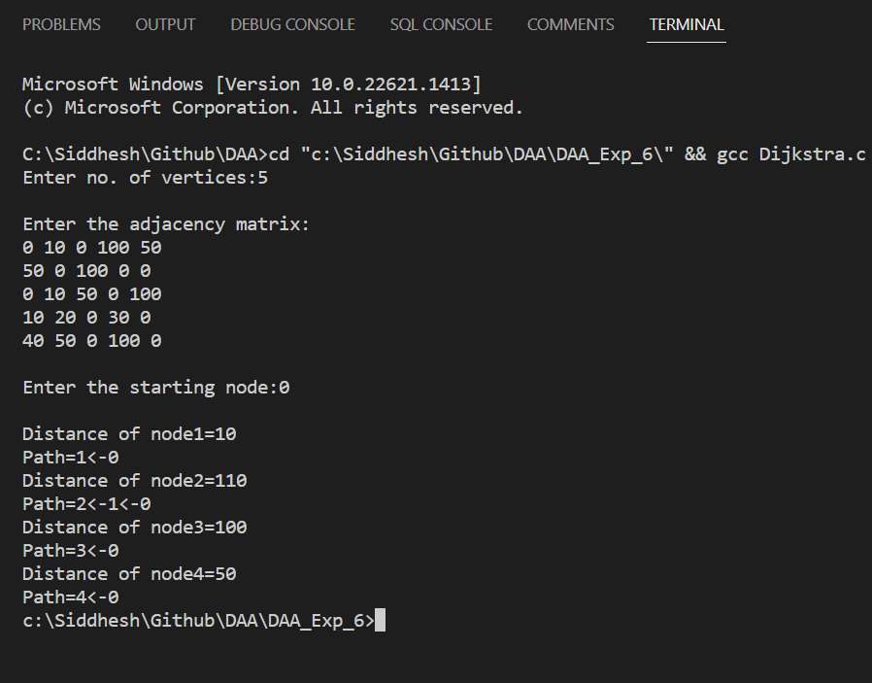

CONCLUSION: | Successfully understood Dijkstra’s algorithm and implemented it in C program to find the shortest path.

